**CI/CD Deployment for Springboot Application**

The code for this project is hosted at   
<https://github.com/VijayMoirangthem/CI-CD-Deployment-for-Springboot-Application.git>

The project is developed by Vijay Moirangthem.

Project Objective:

As a Full Stack Developer, you have to build a CI/CD pipeline to

demonstrate continuous deployment and host the application on AWS

EC2 instance.

Background of the problem statement:

As the project is in the final stage, management has asked you to

automate the integration and deployment of the web application. You

are required to set up an environment where the application will be

hosted and accessed by users. The source code is supposed to be fetched

from a GitHub repository.

You must use the following:

• Eclipse

• GitHub

• S3 bucket

• AWS EC2/ Virtual machine

This section will guide you to:

• Launch and connect to an EC2 instance This lab has three subsections, namely:

1. Write spring boot program.

2. Launching an EC2 instance

3. Connecting to the EC2 instance

4. Creating S3 Bucket.

5.Added jar file in bucket.

4. Pushing the files to GitHub repositories

## **Sprints planning and Task completion:**

The project is planned to be completed in 2 sprint. Tasks assumed to be completed in the sprints are:

* + Creating the flow of the application
  + Initializing git repository to track changes as development progresses.
  + Writing the program to fulfill the requirements of the project.
  + Testing the program with different kinds of User input
  + Pushing code to GitHub.
  + Creating this specification document highlighting application capabilities, appearance, and user interactions.

## **Core concepts used in project:**

• Deployment: to deploy the local project to the end-users.

• Virtual Machine: use virtual instances to help to build, deploy and manage websites.

• Exception Handling: used to catch problems that arises in the code especially in I/O blocks. • Single Web Page: apply the concept of a website that only contains one HTML page.

• Object-Oriented: used to create and model objects for users and their credentials.

**Technologies Used:**

• AWS EC2 instance: to use the instances as a VM and deploy the application

• Jenkins: to build the project from GitHub.

• GitHub: to upload the source code of the project.

## **Flow of the Application:**

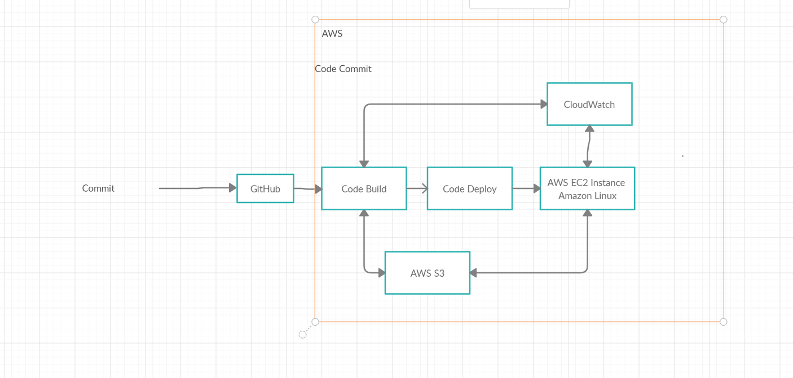

**Project Users Stories : ( Agile and Scrum )**

* As a user I want an automated integration of a Spring boot Application.
* As a user I want an automated deployment of a Spring boot Application.
* As a developer I want to automate the integration of a Spring boot Application for the user.
* As a developer I want to automate the deployment of a Spring boot Application for the user.

**Sprint**

* Understanding the problem statement of the project .
* Creating the flow chart of the project.
* Creating Maven Project.
* Creating Spring boot Application.
* Adding necessary dependencies.
* Testing at each step for different user inputs.
* Initializing the git repository.
* Pushing the code to the GitHub.
* Creating AWS EC2 instance.
* Downloading MobaXterm.
* Downloading Jenkins.
* Deploying the application on Jenkins.
* Creating the Specification document for deploying the project.